**A Student Report Management System**

**Michael Ndigi Mukora**

**137307**

Table Of Contents

Table Of Contents....................................................................................................................................... iii Problem Statement.................................................................................................................................3 Objectives.........................................................................................................................................3-4

Limits and Justifications ........................................................................................................................4

Existing sytems ..........................................................................................................................5-6 Figures.........................................................................................................................................8-9

**Problem Statement**

In today’s modern age a lot of things have been digitized in order to make systems more efficient, but that is not the case for everything. Many schools keep hard copy of student’s reports and attendance, though saving on cost it is inefficient and can be lost at any point in time due to many possibilities such as fires and floods. This can lead to many students records being lost and can inconvenience them when they need to access them. With file based systems it would have both its advantages and disadvantages.

Advantages of file based systems

* Can have an automatic backup
* Data retrieval is much faster
* Quick editing
* Remote Access

Disadvantages of file based systems

* Limited data sharing
* Security problems
* Integrity problems

The system will help make things efficient for both teachers and student as it will be able to accomplish the tasks stated below:

1. Create a student record
2. Modify and delete student record
3. Display all the student records
4. Display class result
5. Display Student Report Card

The system will be developed in C++ and will be running offline without the need of any internet connection.

**Objectives**

1. To analyze problems users, face when using file-based systems in schools.
2. ii. To study existing Student Report Management Systems.
3. iii. To develop the proposed system that assists in Student Reports.
4. iv. To test the proposed system and ensure full functionality.

**Limitations**

In order to access the records one will need a PC in order to view the record due to the fact it is a console app.

**Justification**

This system is being developed in order to help schools that still use traditional means to store and update student records.

**Existing systems**

We shall look at existing systems

**Edmatix**

Edmatix is a user-friendly and intuitive student record management program that runs in the cloud. It serves as a central database for keeping track of all school-related data, such as student fees, academic records, and attendance counts. It is advantageous to the administration, instructors, and parents.

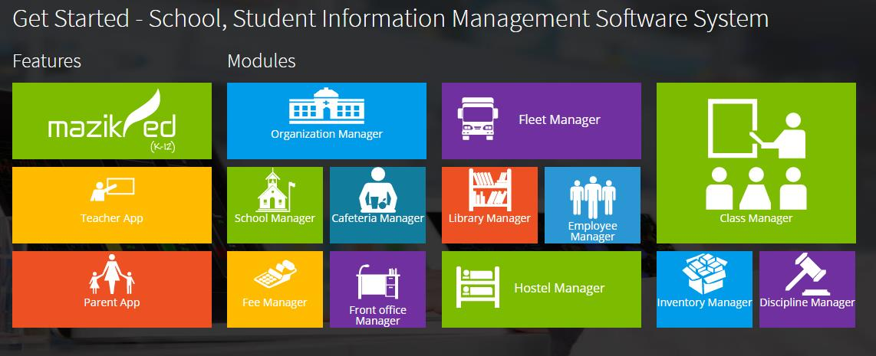

*Figure 1.1 Edmatix*

**Fedena**

Fedena is one of the most well-known EdTech companies in the K-12 and higher education sectors. It is regarded as a safe, scalable, and dependable technology that can be implemented in any size of institution. It's no surprise that it now serves over 40,000 institutions and colleges in more than 200 countries.

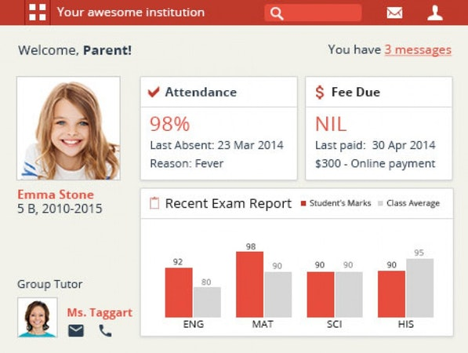

*Figure 1.2 Fedena*

**Alma**

Alma is another cloud-based student record management system that is aimed to make an educational institution's day-to-day operations easier. It is simply customizable to meet the demands of businesses of all sizes. Alma's powerful data manipulation and analysis features are a key element for improved planning and decision making.

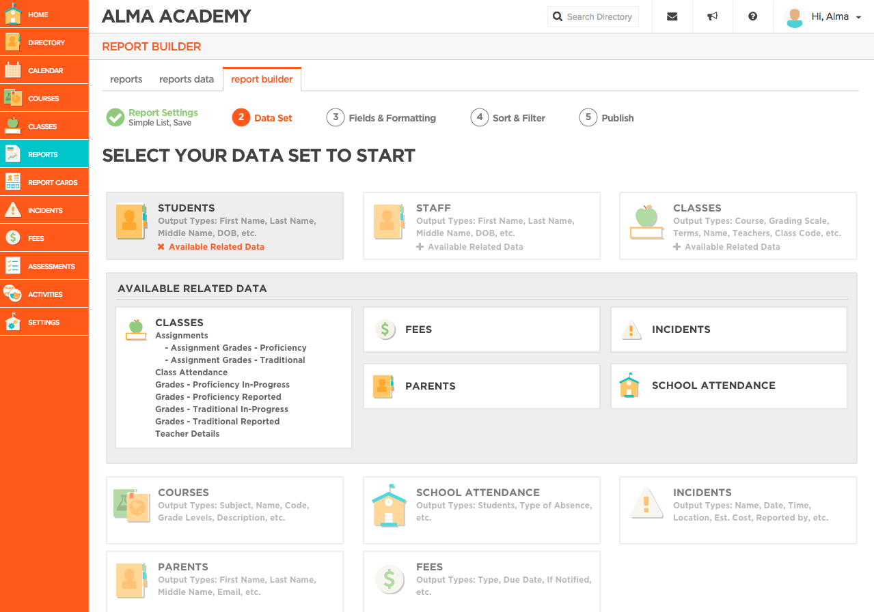

*Figure 1.3 Alma*

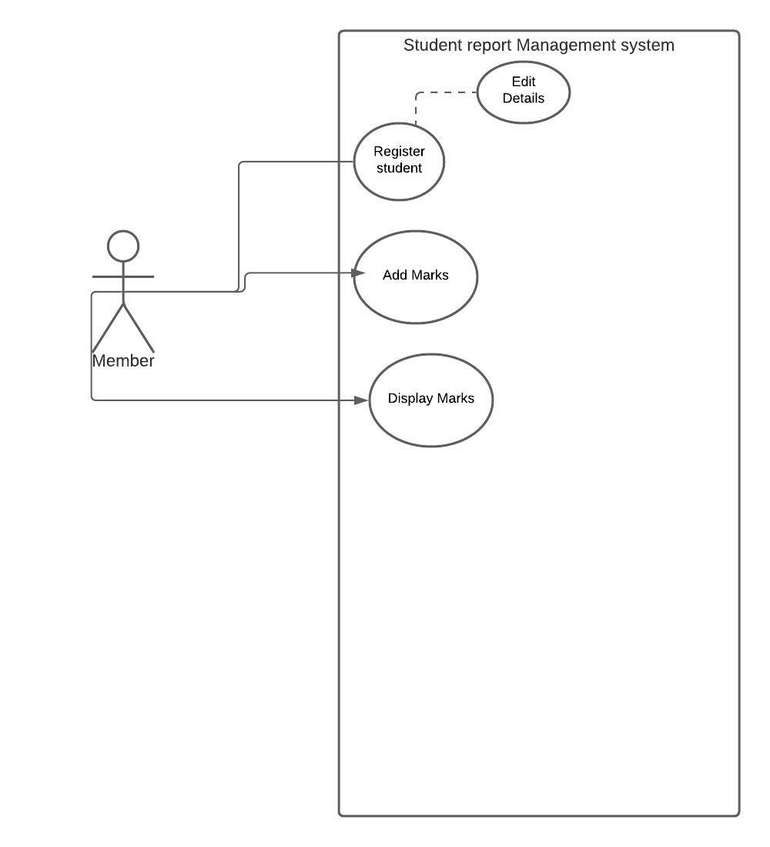

*Figure 1.4 Use case*

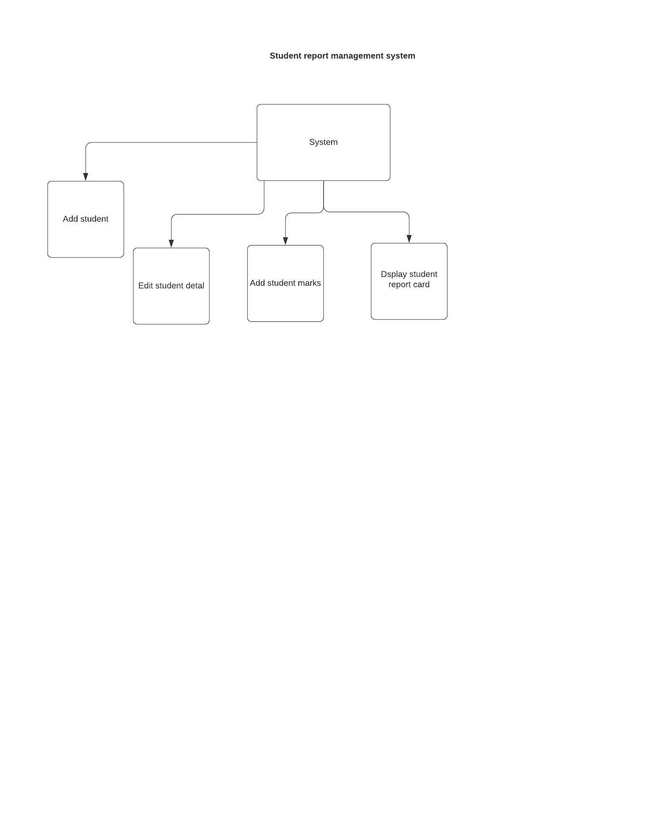

*Figure 1.5 Conceptual Framework*

**Main Menu**

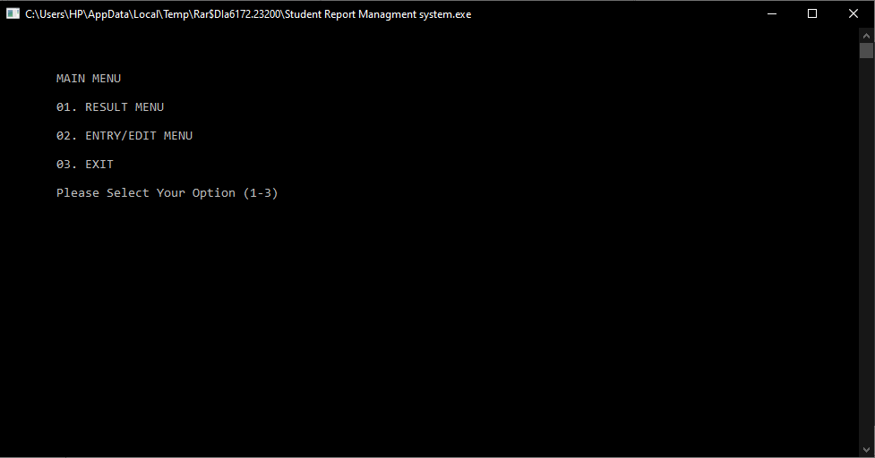

*Figure 2 Main Menu*

**Result Menu**

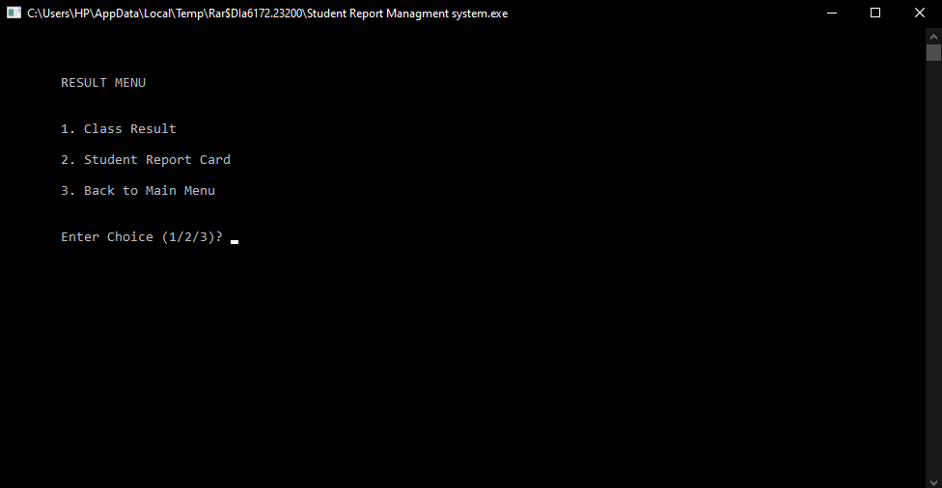

Figure 3 Result Menu

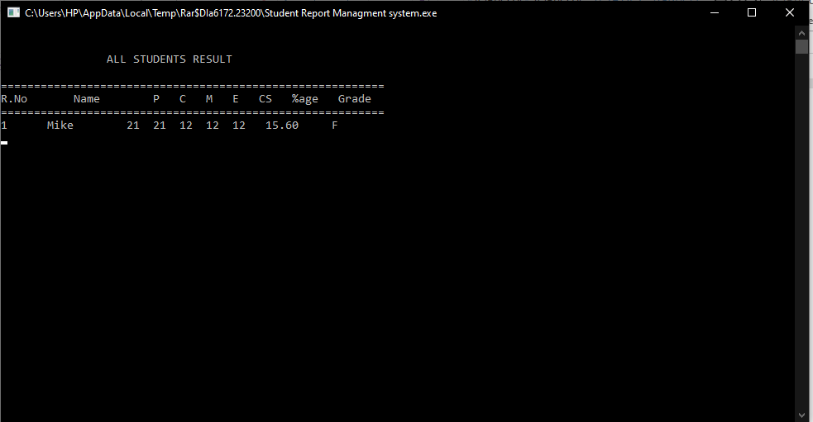

Figure 4 class result

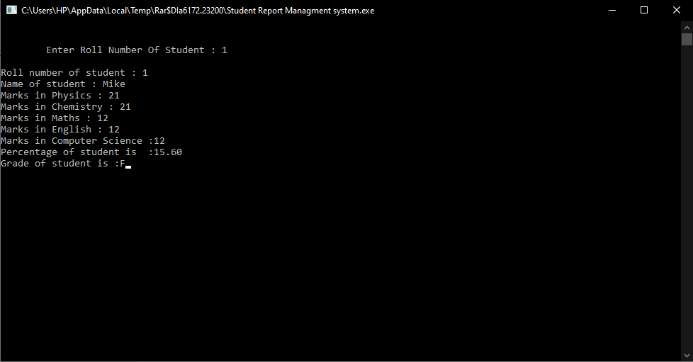

Figure 5 Student report card

**Entry/Edit Menu**